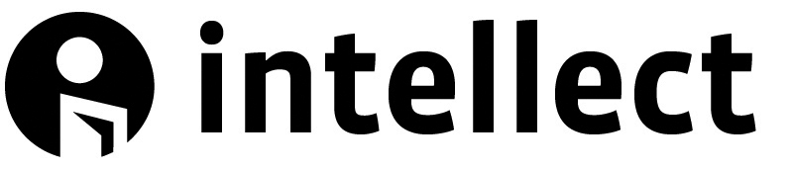

Image copyright

It is the author’s responsibility to obtain written permission from copyright holders for reproducing any images, tables or figures that have previously been published elsewhere. Copyright permissions must be obtained before the book is published or there is a risk of copyright infringement. Failure to procure these rights could result in a delay in publication.

When looking to use material from books/ journals, contact the publisher. For images from a stock agency, museum, library or gallery contact the organization concerned. Photographers hold copyright over photographs. If you are unable to locate the copyright holder or have been refused permission please contact the Intellect Books team for assistance and advise.

The sample letter below can be used as a template when seeking copyright permission.

Dear (copyright holder)

I/ we are preparing a book entitled (name of book) for publication, by Intellect. I/ we are seeking permission to use (state material, page/figure/table number original source.)

We request non-exclusive rights to reproduce the material in the book stated above in print and electronic format in perpetuity. We confirm that full acknowledgement will be given to the source.

Intellect as an academic publisher does not offer any remuneration to editors or authors so we would therefore ask that you would waive or reduce any fees involved in granting copyright.

If you would be happy for the images to also be used in promotional material for (name of book) please state this in your reply. Again, full acknowledgement will be given to the source.

Thank you for your help in this matter. We hope that you will be prepared to provide the necessary permissions. Please feel free to contact us/ me if you require any further information or clarification.

If permission is granted, please sign this form and return it to the address below.

Thank you.

Yours faithfully

(Author name)
(Author address)
(Author email)

Permission is hereby granted:

___________________________
Signature

___________________________
Print Name

___________________________
Date

Copyright statement you require: ____________________________________________________________________________________________________________________________________________________________________________________________________________

Permission is grated for use in promotional material
Yes □ No □

